EMResource® Quick Reference Guide
Update Event Statuses

Overview
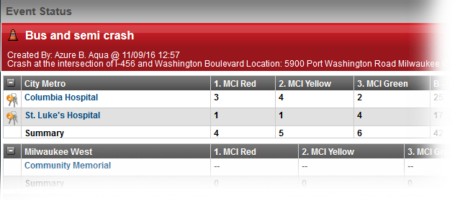
EMResource event statuses allow you to report on situations specific to the type of event. Mass casualty incidents may call for you to report the number of patients by triage category, each of which is represented by a status. It may also be appropriate to report on the availability of equipment or your facility’s decontamination capacity.
Events can also help you manage ongoing, non-emergency situations. Facilities can use a bed availability event to regularly report on the statuses of specific units or types of beds.
Definitions:
- Resources= Hospitals or FSEDs
- Status= Essential Elements of Information (EEI) or data points

To Update Event Statuses
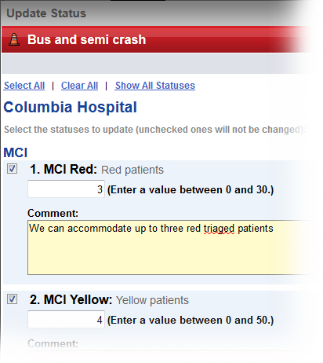
- Click the name of the event in the banner at the top of the page.
- Locate the resource and do one of the following:
  - To update a single status, click its current value.
  - To update multiple statuses at one time, click the resource’s keys icon.
- In the Update Status page, select the check box next to the status you want to update.
- Select or enter the status.
- If appropriate, select the reason for the change.
- If appropriate, in Comment enter a comment on the status change.
- To update additional statuses, repeat steps 3 – 6 for each.
- Click Save.

Juvare envisions a future in which communities are resilient in the face of danger. With precise, vigilant, and connected solutions, Juvare fosters networks of mutual assistance that help organizations bounce forward. For more information, contact Juvare Support at 877-771-0911 or support@juvare.com.
EMResource – Update Event Statuses QRG © 2018 EMSystems, LLC, a subsidiary of Juvare Corp. Page 1 of 1

