Quick Reference Guide: Medical Resource Request
Always work within the Incident Command System. Be prepared to justify the request.
*All local resources must be exhausted prior to requesting state or federal assets.
To place a resource request: Log into the COHDIMS site. www.cotshil.org And scroll down to the Regional Resource Request section.
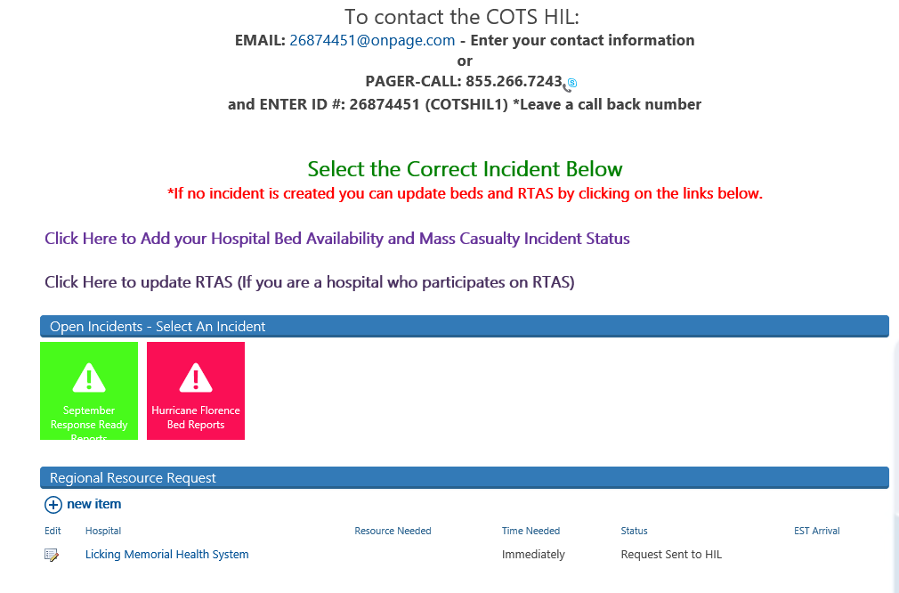
Select new item

Complete the form and save it. The save button is located on the top left side.
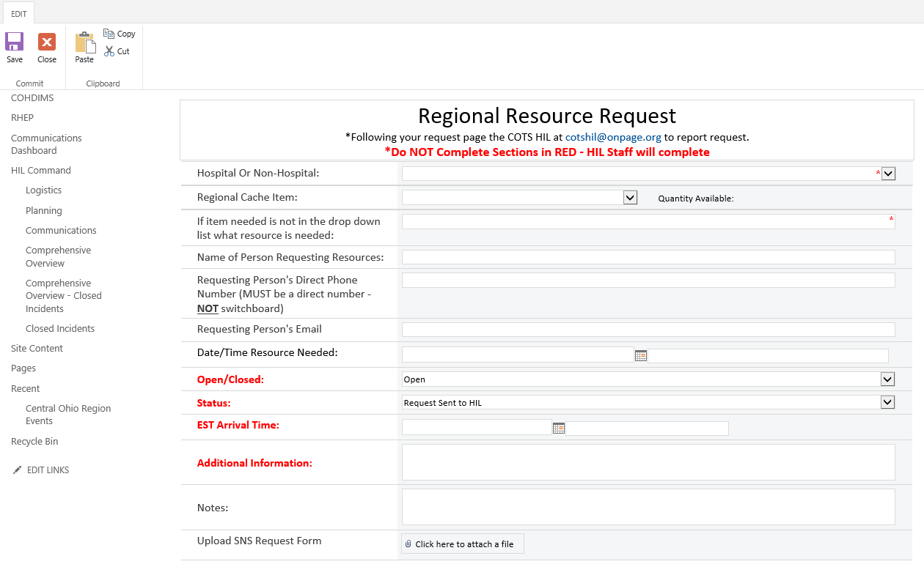
Complete the sections in black. The red sections will be completed by the requestor (your agency) during the delivery and completion of the resource request.
Depending on the resources requested, additional documentation may be needed. Additional documents are located on the right side of the COHDIMS site under the General Incident Documents section. The forms can be downloaded to your computer completed/saved and uploaded into the resource request.
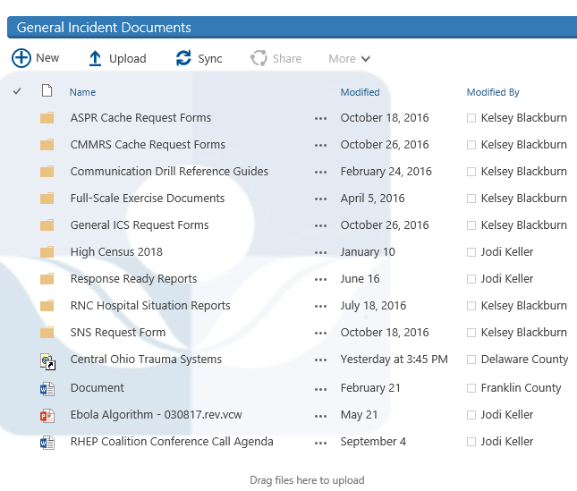
Once the request is saved, it will appear on the COHDIMS site in the Regional Resource Request section.
Page the Healthcare Incident Liaison (HIL) to inform them of the request. There are two ways to page the HIL:
- Dial 1-855-266-7243 and enter ID: 26874451 (COTSHIL1). Be sure to enter/verify your contact phone number.
- OR Send an email to 26874451@onpage.com
The HIL will acknowledge the resource request and determine further actions. The HIL will assist with resource coordination, but not with transportation or delivery of the cache items.
Once the cache items have been received, please update the status on COHDIMS by clicking on the edit button by your hospital.
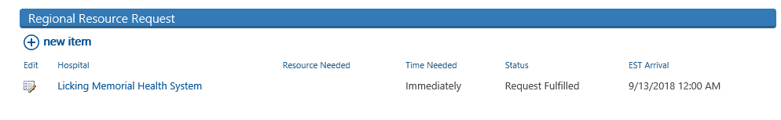

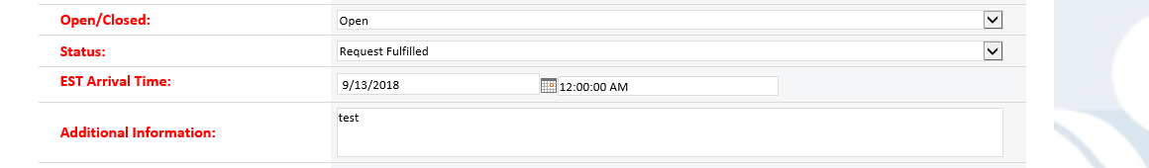

To close a Resources Request:
Once the resource is no longer needed the following steps will be completed:
- Coordinate the resource return with the agency you acquired the resource from
- Ensure necessary documentation is completed and uploaded to COHDIMS
- Edit the request on COHDIMS to show the status as “closed” by editing your hospitals request
- Notify the HIL and they will close the request from on COHDIMS

Cache Name | Contents | Request Procedure
ASPR Regional Caches *  Administration for Strategic Preparedness and Response | Lists on COHDIMS in the Resource Request drop down:  Not inclusive list:  - BluMeds  - Ventilators  - MCI Trailers  - Decon Trailers  - Morgue Trailers  - Wheelchairs  - Cooling Fans  - Traffic Cones  - MedSleds | For these and other ASPR resources not listed here, follow the following steps in any order.  Step 1) Enter a Resource Request on COHDIMS www.cotshil.org  Step 2) Notify the COTS HIL Call  855-266-7243 Enter ID: 26874451  OR Email: 26874451@onpage.com  Be sure to enter a good call back number!  Step 3) Contact your local EMA
CHEMPACK  (Federal Cache -  ODH has Ownership) | Atropine (Atropen)  Diazepam (Valium)  Mark 1 auto injectors  Pralidoxime (2Pam)  Sterile water  (Two Types: EMS and Hospital)  Chempacks can be Pre-Positioned during Special Events  - Notification to ODH at least 7 Days prior to event  - Requires ODH Approval (significant risk identified)  - ODH notifies CDC  Requesting Facility’s Requirements  - Locked Storage with 24-Hour Security or Intrusion Device  - Climate Controlled (68-77 F degrees)  - DEA Registration or Exemption  - Liable for all Costs (transport, etc) | Non-Host Hospital Request Procedures  - Identification  - Notification to Pharmacy Department  - Call the HUB 866-599-5377  - Provide requested information  - OPHCS Alert  - Identify closest Assets  - Verification  - Transport via Law Enforcement  - Receipt of Chempack to the Hospital  - Complete Controlled Substance Form  - Shelf Life Extension Program (SLEP)
Host Hospital Request Procedures
- Identification
- Host Hospital personnel (per SOP) report to Chempack storage area and obtain all or a portion of the cache.
  - Based on the incident the host hospital determines whether to keep all of the cache or send portion to another location
  - Call the HUB 866-599-5377 to report assessment.
  - Hospital Chempack is divided into thirds using a dot configuration system (chart on the outside of each container)
  - EMS Chempack are not pre-divided
Demobilization
- Determine Situation is Resolved
- Notify the HUB 866-599-5377
- Perform Inventory of Returned Supplies
- Contact ODH and CDC for Disposition of Assets
SNS  Strategic  National  Stockpile | Last Resort.  *Use ONLY if all local and regional resources are exhausted  Airway maintenance supplies  Antibiotics  Antitoxins  Burn and blast supplies  Chemical antidotes  IV administration  Life-support medications  Medical/ surgical items  ANY MEDICAL MATERIAL CAN BE REQUESTED | Submit 213RR SNS Request Form following your local  county process either through local Public Health or  local EMA.  The 213RR Form is available on COHDIMS under Incident Documents
Process for PPE and Ventilators during the COVID-19 Response due to national supply shortages
Virtual PPE Stockpile | Personal Protective Equipment (PPE)  - Gowns  - Gloves  - N95 Masks | Requesting Procedures for LTCFs  - LTCF has a shortage of PPE and a COVID-19 outbreak they request PPE assistance from their partner hospital and/or local coalition  Requesting Procedures for Hospitals  - Hospital has a shortage for PPE or other medical supply, contact the COTS HIL (26874451@onpage.com) or RHC (jkeller@centralohiotraumasystem.org) with the item needed and contact person  - COTS HIL or RHC will notify Zone Clinical Lead and send an email to the other region and zone hospitals requesting assistance  - If unable to procure in our region or zone, the COTS HIL or RHC will work with the other regions in the state
State Ventilator Cache | Phillips Trilogy EV 300 | - Complete ventilator 213RR form  - Send to COTS HIL or RHC to obtain Zone 2 Clinical Leads signature  - Once signature is obtained send to local EMA to forward to state  213RR Ventilator Request form is available on  COHDIMS under Incident Documents
*The COTS HIL can obtain additional healthcare supplies or equipment for hospitals that are not specifically listed in the cache, through other hospitals and healthcare partners in the State.
For items needed and not listed, please call the COTS HIL.

