EMTrack is a web-enabled platform for tracking patients, primarily during Mass Casualty Incidents and facility evacuations. Incidents will be created by the COTS Healthcare Incident Liaison (HIL). This PHI-compliant product supports identification card scanning and importing into the patient record, and the use of 2D, 3D, and QR codes. EMTrack is available on the web, Apple App Store, and Google Play.
- Login to EMTrack: https://emtrack.juvare.com/dashboard
Enter your individual username and password. If you need a username or password, please contact a COTS staff member for assistance.
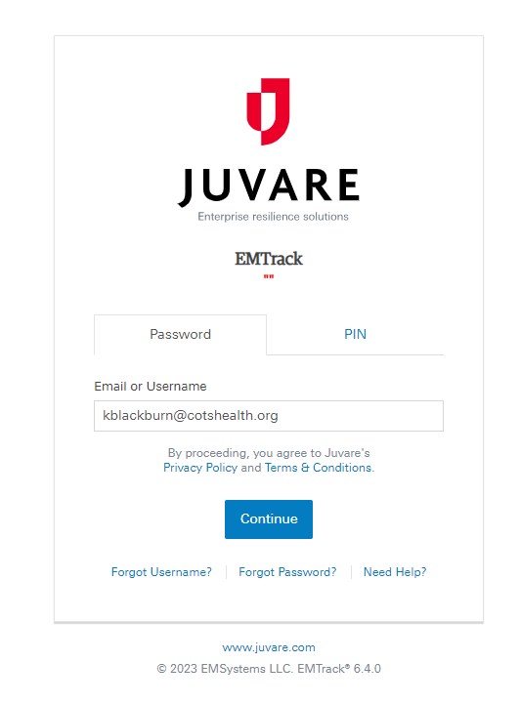
- Once logged in you will be on the dashboard – there may be multiple incidents created. You will navigate the incident by clicking on the drop-down menu “Incident Mode”.
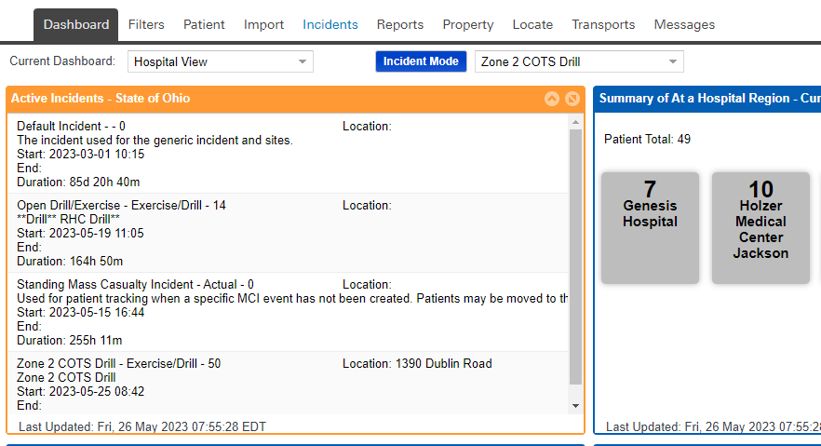

Individual Patient Entry
- To enter individual patients, you will click on the patient tab, then click Hospital Triage + Intake.
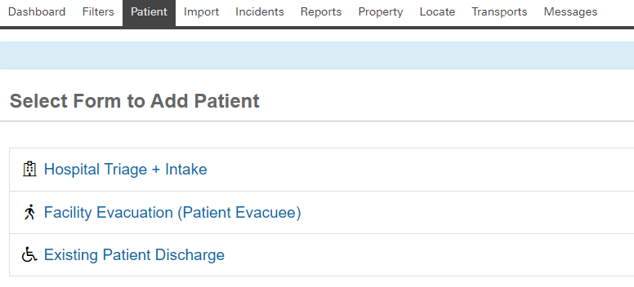
- Enter the patient information, pay attention to * required fields. Three KEY points.
  - Make sure to select the incident in which the patient is involved with.
  - The Patient ID/Triage Tag # is a required field and requires a number this should be the region initial/hospital abbreviation/0001 (i.e. SEHOLJ001, SEHOLJ002) = SE region/Holzer Jackson (i.e. CENWMH001, CENWMH002) = Cen region/Wyandot Memorial Hospital.
  - Make sure to include the current location of the patient. (i.e. Your Hospital)
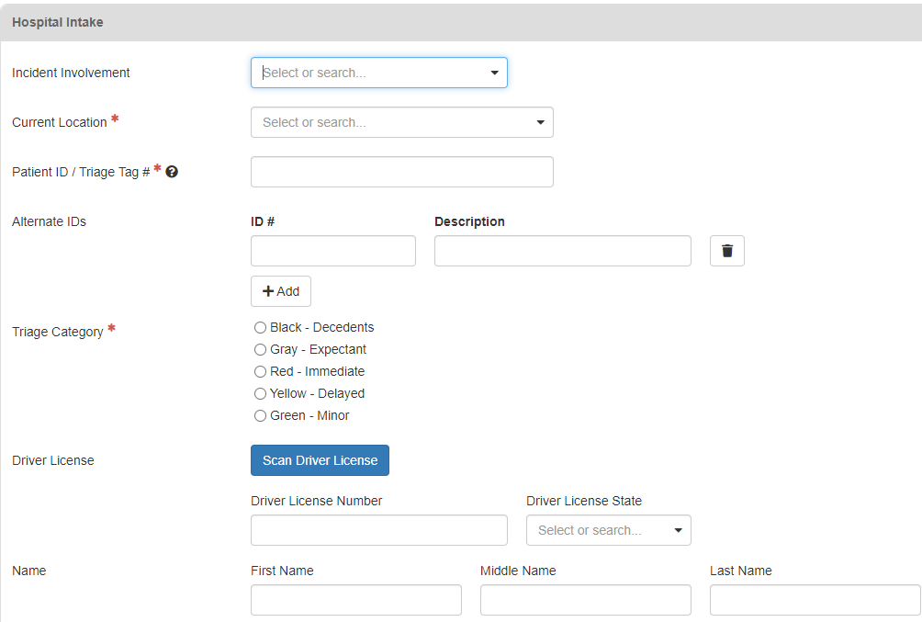
Enter format discussed above: (i.e. SEHOLJ0001)
Select Incident
- Once the patient is saved, they will populate in the incident. You will navigate back to the dashboard.

Locating Patients:
EMTrack is designed to aid you in ensuring only qualified users have access to patients' and clients' protected health information (PHI). Users must only access the patient records necessary to perform their job, and to provide or coordinate patient care and movement.
To aid in compliance with HIPAA standards, EMTrack automatically logs user actions that provide or could provide access to client details, including PHI. This provides the support needed when an action must be traced to the date and time it occurred, as well as the user who performed the action.
- Click on the Locate tab.
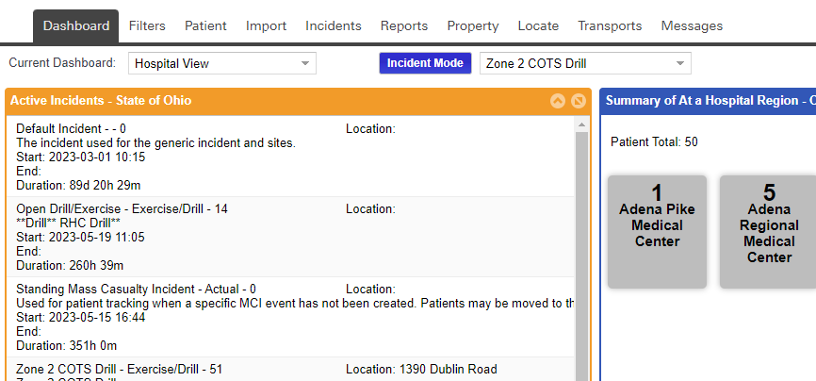
- Click on add search term by clicking on the drop down (i.e., if you have the patient’s name – select first name or last name; if you have the age – select age). Then add the search criteria (i.e., first name, age, etc.) in the open text box and click search.

Glenn
Select search term
Enter the search criteria
- The patient (s) you searched for will then show up based on the search criteria entered.
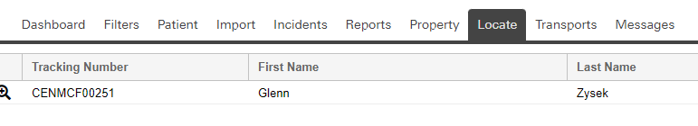
Moving/Discharging Patients:
- From the dashboard – under all active patients find the patient you are receiving or discharging and click the magnifying glass.
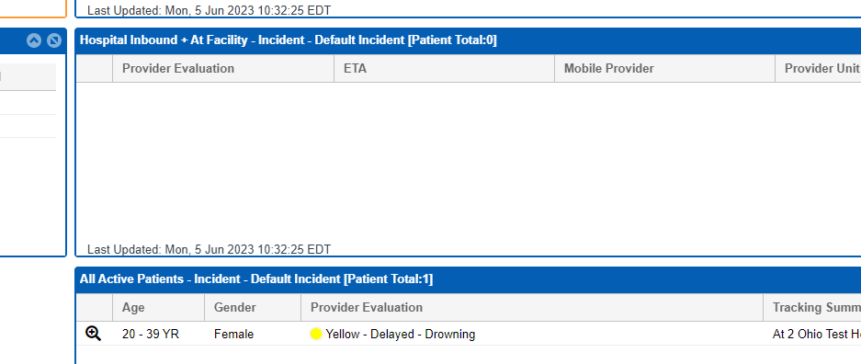
- Once you click on the magnifying glass you will click discharge if the patient is being discharged. *Once the patient is discharged, they will no longer show up on the patient list.
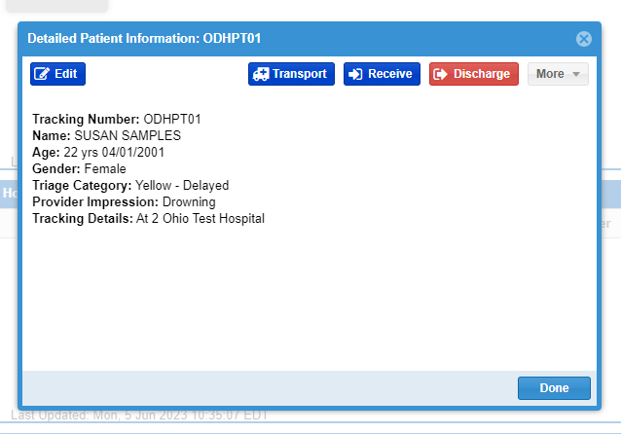
- If the patient is being received at your facility you will click on receive and select the new location.
- You can also edit the patient details and change status by clicking on edit and clicking through each tab to make necessary changes and clicking save and exit.
