COTS QUARTERLY COMMUNICATION DRILLS (Hospitals/FSEDs)

WHEN: Quarterly morning or evening shift. This drill may be announced or unannounced. The objectives must be completed within one hour after the drill begins except for the COTS Surge Team Conference Call which occurs after the other drill objectives are completed.
FIRST: Log on to EMResource: https://emresource.juvare.com/login
You can also access EMResource through a link on the front page of the COHDIMS site. www.cotshil.org. Enter your hospital’s password to gain access. If you already have a 365 account and need to sign into your hospital account see Attachment A.

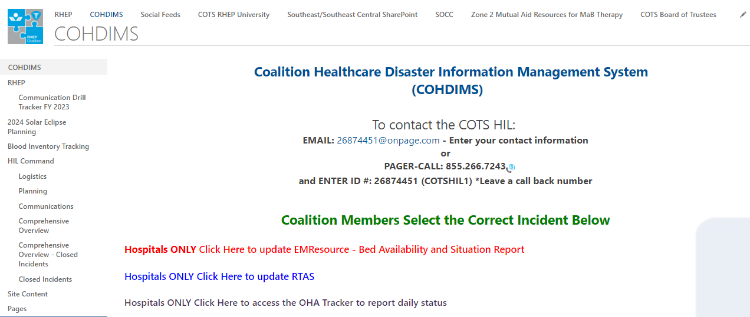
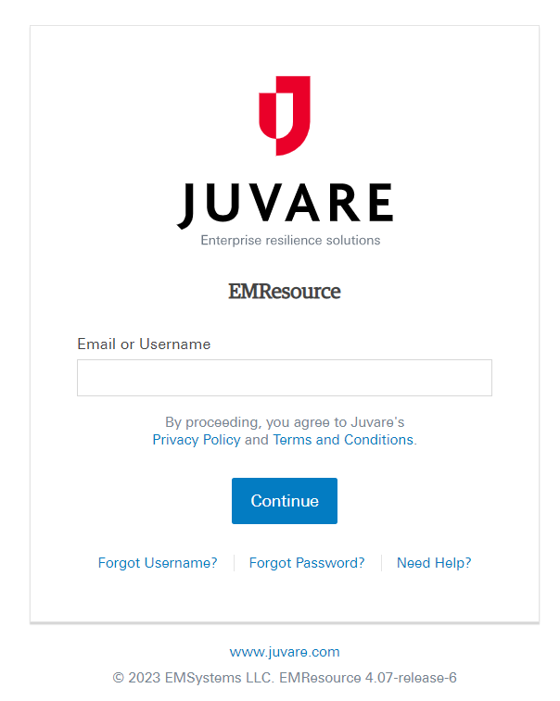
Each use has an individual login for EMResource

OBJECTIVE #1 – ENTER HOSPITAL/FSED Updates on EMResource

Update Event Statuses

Overview
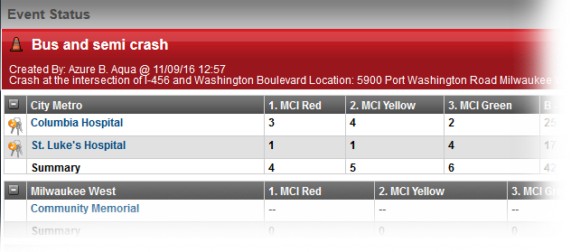
EMResource event statuses allow you to report on situations specific to the type of event. Mass casualty incidents may call for you to report the number of patients by triage category, each of which is represented by a status. It may also be appropriate to report on the availability of equipment or your facility’s decontamination capacity.
Events can also help you manage ongoing, non-emergency situations. Facilities can use a bed availability event to regularly report on the statuses of specific units or types of beds.
For the monthly communication drill please ensure you select the Monthly Communication Drill Event for the appropriate region (Central or SE/SEC) at the top of the webpage. For other exercise or real-world events ensure you select the appropriate event.
Definitions:
- Resources= Hospitals or FSEDs
- Status= Essential Elements of Information (EEI) or data points

To Update Event Statuses
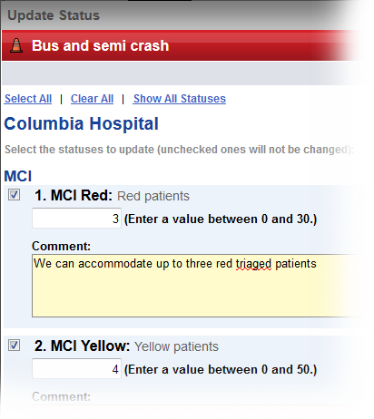
- Click the name of the event in the banner at the top of the page.
- Locate the resource and do one of the following:
  - To update a single status, click its current value.
  - To update multiple statuses at one time, click the resource’s keys icon.
- In the Update Status page, select the check box next to the status you want to update.
- Select or enter the status.
- If appropriate, select the reason for the change.
- If appropriate, in Comment enter a comment on the status change.
- To update additional statuses, repeat steps 3 – 6 for each.
- Click Save.

OBJECTIVE # 2 – REAL TIME ACTIVITY STATUS (RTAS)
RTAS link: https://www.cotsrtas.org/login

Hospitals can also use the link provided on the COHDIMS Homepage to access the RTAS website. Hospitals must have a password to enter the site.

COHDIMS link to RTAS-Step 3:

RTAS Homepage:
Enter username and password here.
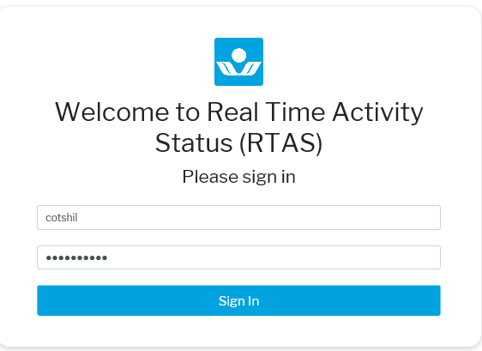

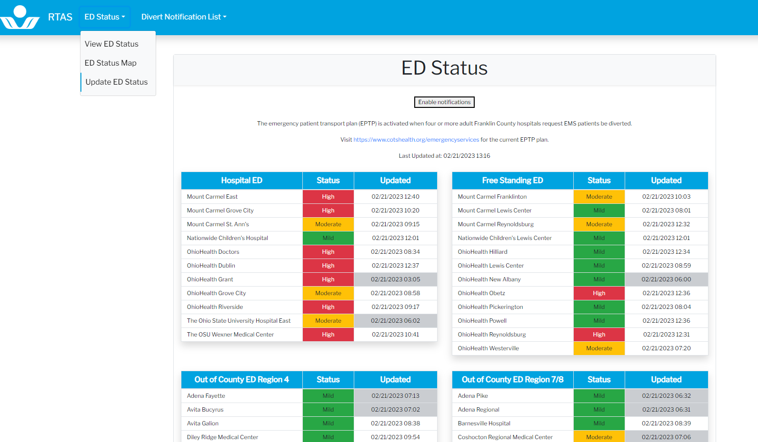
Go to Update ED Status
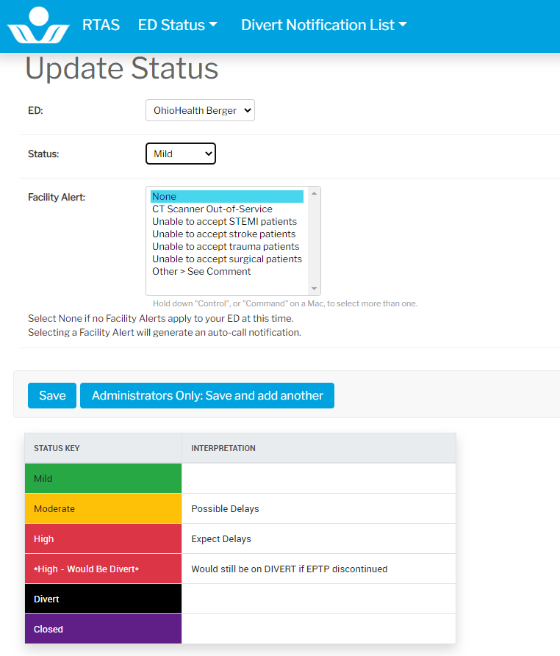

Update information and select the “Save” button

OBJECTIVE #3 - MARCS (RADIO)

Call the COTS HIL over your MARCS Radio on the XHOSP-CEN talk group for the Central Region and XHOSP-SE for the SE/SEC Region to report that all exercise objectives have been completed. * Hospitals will not use acronyms over the MARCS radio; but will speak the entire hospital name. Important: Do not talk over another hospital or the HIL when reporting. Ensure no transmissions are going on when you call. When pushing the “push to talk button” wait for the chirp noise to be done before talking. When finished talking release the push to talk button.
Example:
- You: This is (your hospital name) to the HIL
- HIL: Go ahead (hospital) this is the HIL
- You: (your hospital name) is completing the MARCS check for the drill
- HIL: (Hospital) your time of MARCS check completion is at (time)

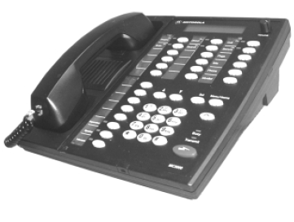
Zone-UP Button

T
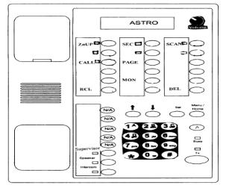
Following the exercise, please be sure to reset your radios to your hospital talk group by pressing Menu/HOME button once.
Talkgroup
Arrows

OBJECTIVE # 4 – CONFERENCE CALL

Conference call with scenario:
- No Notice Drill schedule: FY 2024 August, November, March, and May. This schedule could change depending on other exercises or real-world events.
- Conference call information will be included in the Conference Call Agenda Word Document attached in the EMResource Communication Drill Event along with the scenario.
- It is recommended hospitals gather a small team to discuss the scenario at each hospital (act out the scenario how your facility would like to). The COTS Surge Team Conference call agenda Word Document should be used to prepare and take notes during the conference call.
- Attendance and scenario report will be documented during the call and 100% participation is required.

*COTS MONTHLY COMMUNICATION Drill Complete

ODH QUARTERLY MARCS RADIO CHECK

WHEN: Quarterly; The First Thursday between hours of 09:30 – 11: 30 for the Central Region and 10:30 to 12:00 for the SE/SEC Region.

STEPS TO COMPLETE THE DRILL
- Ensure MARCS Radio is sitting on and monitoring your individual hospital talkgroup.
To set your radio to your individual hospital talkgroup, hit the Menu/HOME button once.
- ODH will call out your hospital’s name over your talkgroup. (Example: “Wyandot Memorial Hospital, do you copy”?)

- Respond to ODH: (Example: “This is Wyandot. We copy”.)

To respond, push and hold down the “Transmit” button on lower right corner of your radio (desktop). You will hear a “chirp” indicating it is ok to talk. Continue to depress the Transmit button for the duration of your message. When finished speaking, then release.
*If you missed your initial call-out from ODH, you may contact ODH over the XODH-CALL talkgroup during the following days. Use the Zone-Up Button to move through the zones; use the Channel Button to scroll through the talkgroups. *Please remember to return your radio to your individual talkgroup!

- Free Standing Emergency Department and Surgical Hospitals: COTS will call over the MARCS radio between 10:00 am and 11:00 am. COTS will send a report following the check and conduct make -up checks as needed.
COTS will call the FSEDs and specialty surgical hospitals since ODH does not contact them.

ODH RADIO CHECK COMPLETE

NATIONAL DISASTER MANAGEMENT SYSTEM (NDMS) DRILL (CENTRAL REGION – SPECIFIC FRANKIN COUNTY HOSPITALS ONLY)

WHEN: Periodically as required by the Department of Health and Human Services (DHHS). You will be notified by COTS via TENS alert, if applicable, of an upcoming NDMS Drill, usually 1-2 days prior. An additional TENS Alert will be sent approximately one hour prior to the drill completion deadline as a reminder only.
STEPS TO COMPLETE NDMS DRILL:
1. Follow the same steps as listed under COTS Communication Drill for Objective 1 to enter Bed Availability Information.

*This exercise does NOT require calling in over MARCS Radio unless otherwise specified.
NDMS DRILL COMPLETE

Attachment A:

If you already have an Office 365 account and need to login to your hospital account:

Access COHDIMS

- Type www.cotshil.org directly into the URL line. Do not sure the search bar.
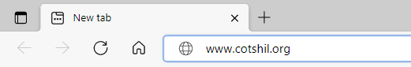

- If you already use Office 365, you need to log in under a different account.
  - In the upper right corner of your browser, click on the 3 dots to open Settings.
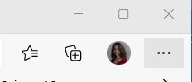
  - Click on New InPrivate Window
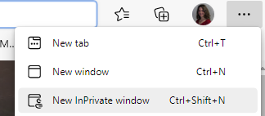
  - This will open a New InPrivate tab.
  - Type www.cotshil.org into the URL line

- The Microsoft Sign in box will appear.
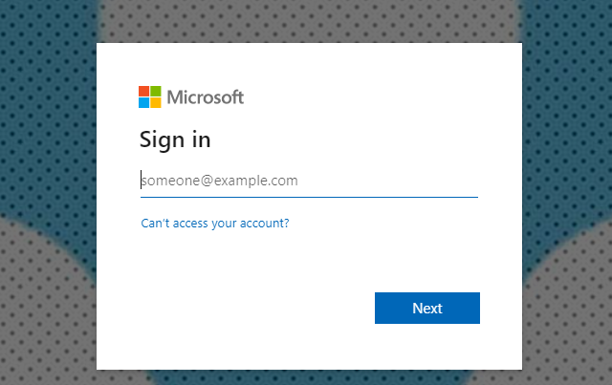

Type in the Username: (Generic username for your agency)@centralohiotraumasystem.org and click Next

Enter the Password and click Sign in

