COHDIMS Completing a Situation Report
Step by Step Instructions for Healthcare Coalition Partners

Website: www.cotshil.org
This document covers:
- Logging into COHDIMS
- Opening the Incident Tile
- Reviewing the Incident Information
- Completing a Situation Report
- Editing a Situation Report
Username: (Generic for each county)
Password: (Generic for each county)

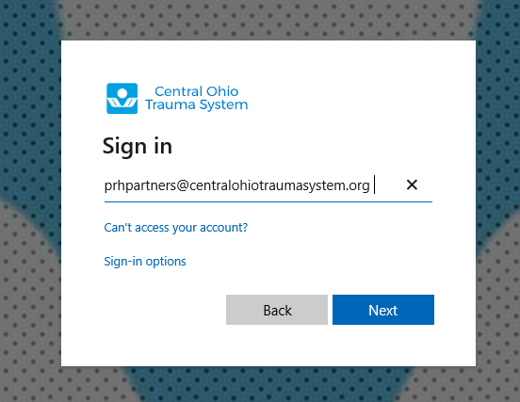
CC

Ensure you are using the proper log in information. If you can’t access, try opening the site in a different browser

Access COHDIMS

- Type www.cotshil.org directly into the URL line. Do not sure the search bar.
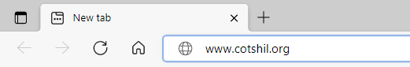

- If you already use Office 365, you need to log in under a different account.
  - In the upper right corner of your browser, click on the 3 dots to open Settings.
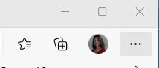
  - Click on New InPrivate Window
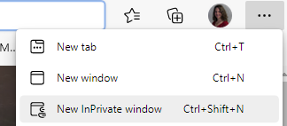
  - This will open a New InPrivate tab.
  - Type www.cotshil.org into the URL line

- The Microsoft Sign in box will appear.
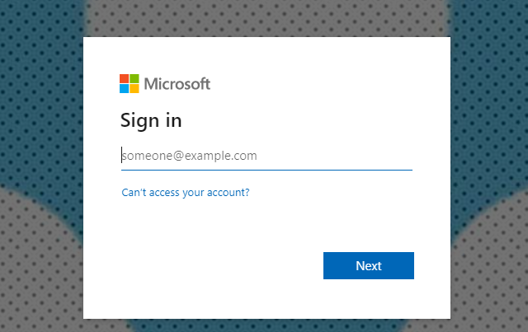

Type in the Username: (Generic username for your agency)@centralohiotraumasystem.org and click Next

Enter the Password and click Sign in

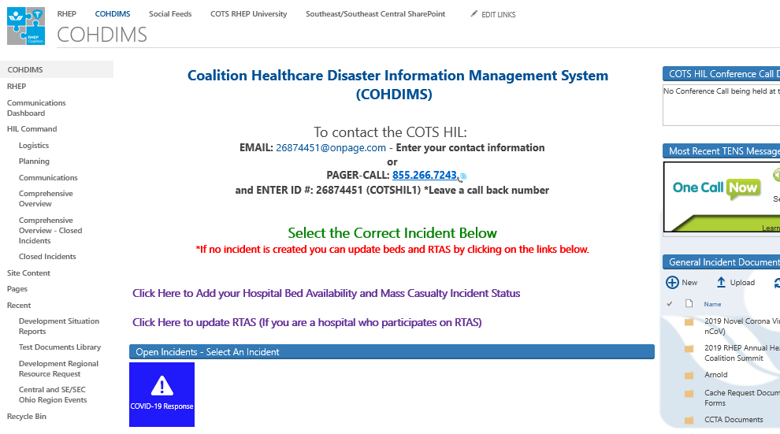
Next: Click on the colored drill tile and it will take you to the next screen. Make sure you click on the words in the tile.
Review the Current Incident and Incident Update sections:
Note: There will be an incident established for the Monthly Communication Drill. There could be an additional incident if we end up having a response to another incident, i.e.. weather related. So, ensure you always click in the appropriate tile.
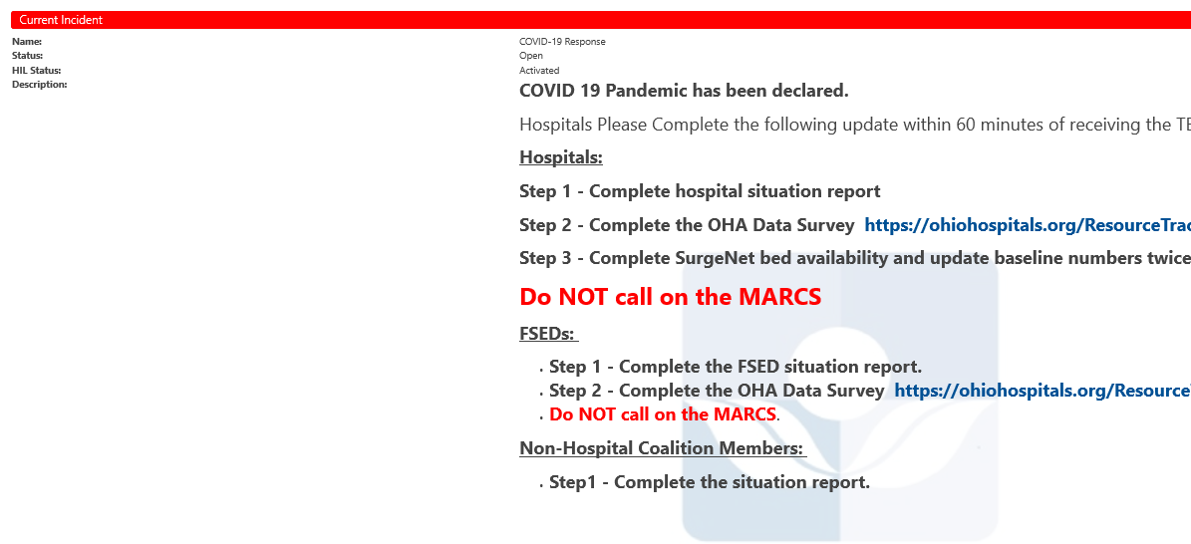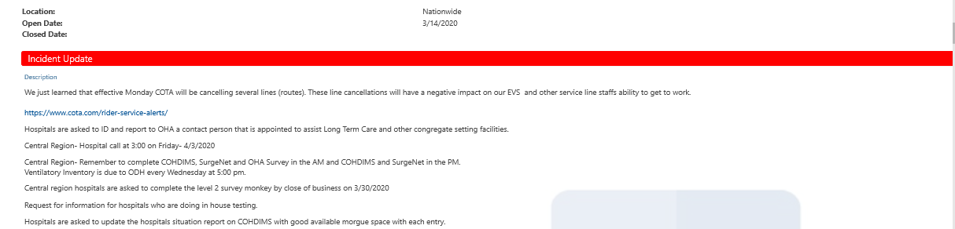

Scroll down and click on Step 1: Click Here to Add Your Contact Information and Situation Report:
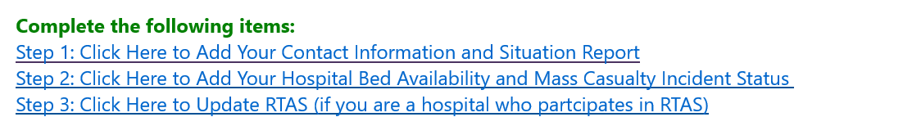

Click the dropdown and select the type of coalition partner you are. Information gathered will vary by facility type:
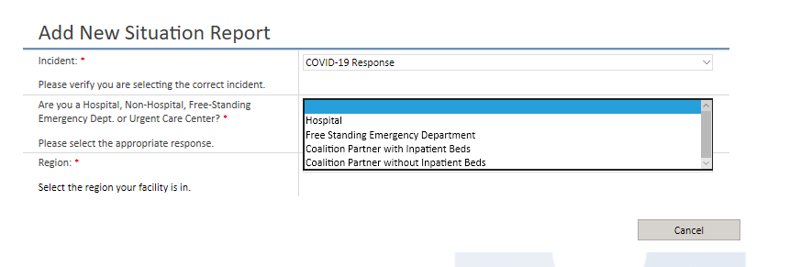

Click the dropdown and select the region: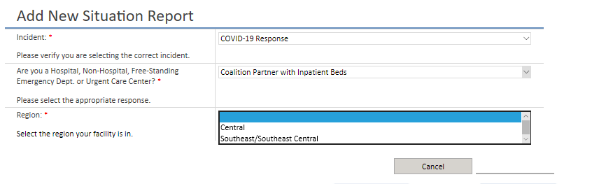

Answer the questions in the Situation Report and select the Submit button. A * is a mandatory question. Ensure you enter good Liaison contact information.
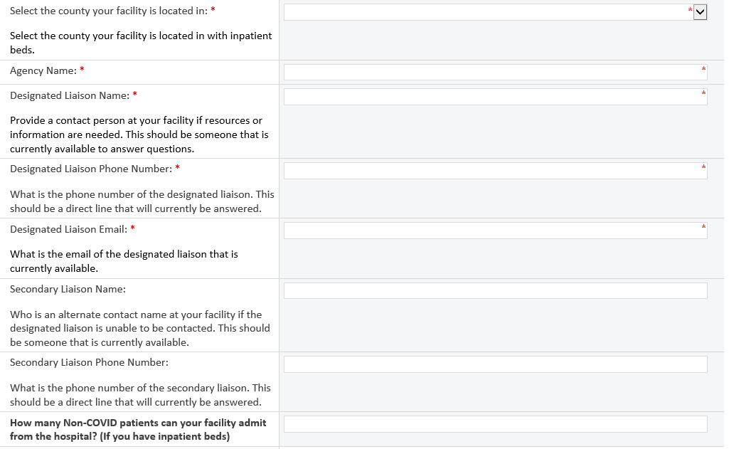
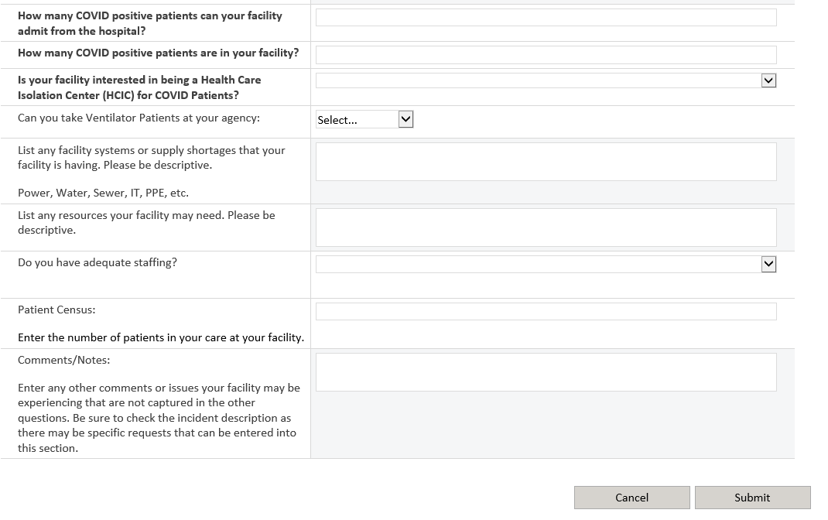

Once you submit your Situation Report you will receive a confirmation:
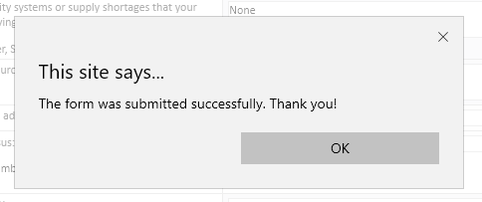
Click OK
You will be able to view your agency on the COVID-19 Response main screen. Scroll down to your Situation Report Section. You may need to refresh your screen to see the update. Ensure you see your agency.

Note: If there are a lot of agencies listed your agency may be on the next page, scroll down to the arrow:

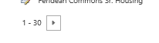

Note: You can change the view on the Situation Report to view your facility easier:
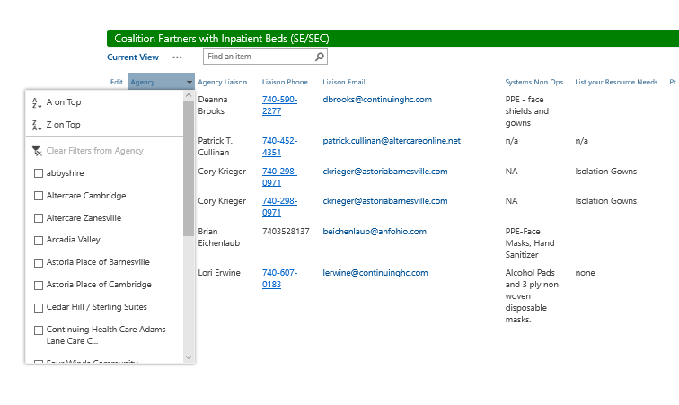
Click on the down arrow and select your facility or filter in alphabetical order.

How to Edit your Situation Report on COHDIMS. You can Edit your report, so you don’t need to complete a new one each time. On the main incident screen, locate your agency name and select the Edit icon:
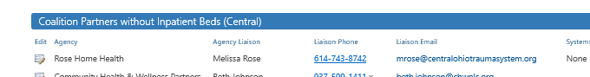

Update the information as needed and click the Submit button. You will receive a confirmation “The form was submitted successfully. Thank you!”
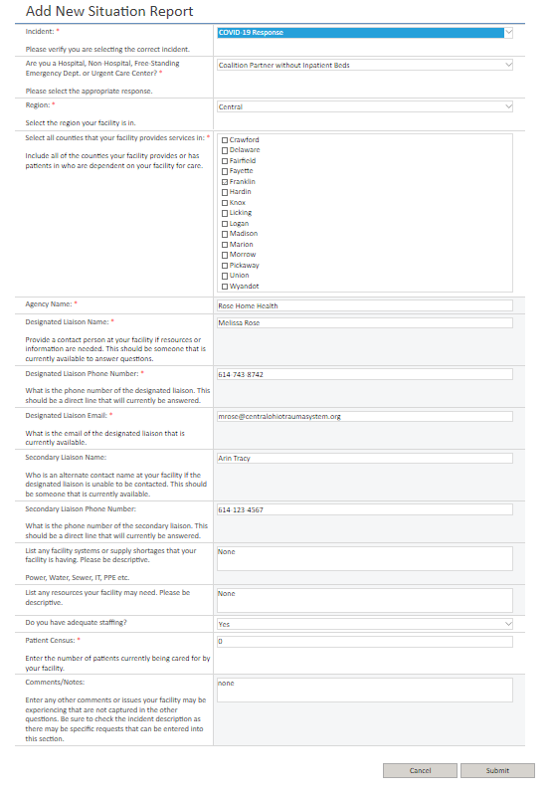

On the main page you can also:
See call in information for conference calls. Note: Not using for COVID-19 Response. Meetings are sent via email on a pre-determined schedule.
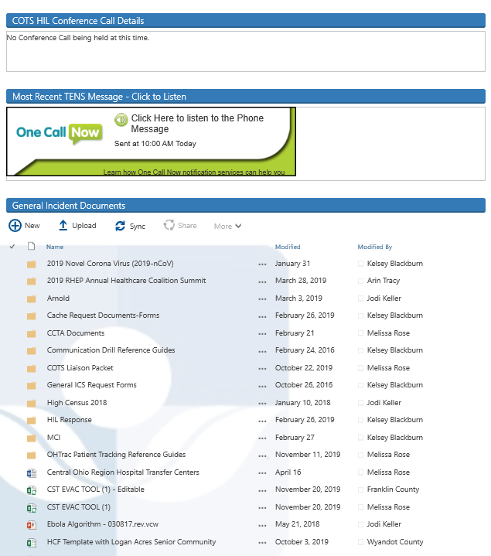
Incident documents.

Hear the last TENS message that was sent.

