+Real Time Activity Status (RTAS)
All Zone 2 hospitals are entering ED status in RTAS at least twice daily as of Feb. 1, 2022.
Hospitals should use the link provided on the COHDIMS Homepage to access the RTAS website. The HIL and hospitals must have a password to enter the site (See Attachment F – Passwords).
COHDIMS link to RTAS-Step 3:
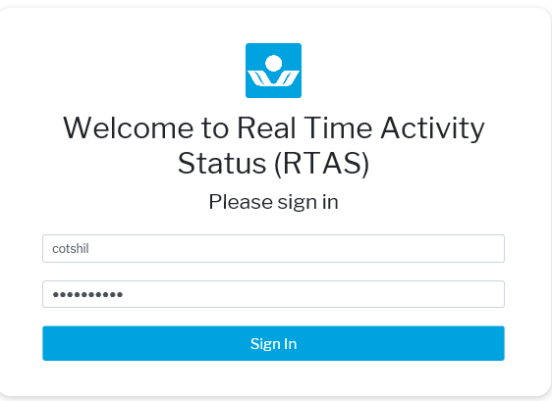
RTAS Homepage:
Enter username and password here.

RTAS Homepage Screen Shot
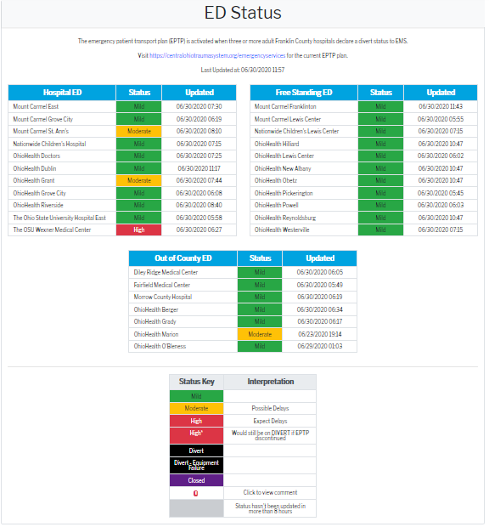

Date | What changed | Updated by
4/20/2022 | Added that ALL Zone 2 hospitals are updating RTAS at least twice daily | J. Keller

