EMResource® Quick Reference Guide for Blood Bank Status
Purpose: The purpose of this document is to provide guidance to the blood bank leadership and other
staff who may update hospital blood status in EMResource.

Monthly Drills: Zone 2 (regions 4, 7 & 8) will conduct monthly drills to evaluate the ability for hospitals to
update their blood status in EMResource and validate the appropriate people are listed in the TENS mass
notification system.

A TENS alert will be sent the first Wednesday of the month to the blood bank group at 9:00 a.m. requesting
updates in EMResource by 10:00 a.m.

Overview of Terminology in EMResource
A resource is an entity that reports a status.
These can be facilities, organizations, and agencies that report information on blood bank capabilities.
Definitions:
- Resources= Hospitals or FSEDs
- Status= Columns of Essential Elements of Information (EEI) or data points (i.e. Blood Type)
Status
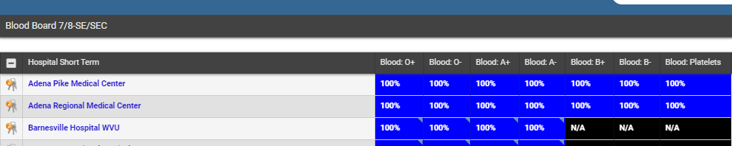
Resource

To Update Blood Bank Status
- Login to EMResource: https://emresource.juvare.com
  - Each individual user should have an account. If you need an account please contact Jodi Keller – Central Region (jkeller@cotshealth.org) or Kelsey Blackburn – SE/SEC Region (kblackburn@cotshealth.org).

- Once logged in click on the drop-down area under the view tab – this is the second drop down in the top left of the page

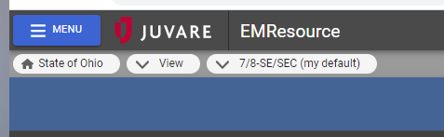
Click on the drop-down arrow

- Then click on Blood Board Zone 2 (4+7/8) - This will navigate you to the Blood Board view for Zone 2 (4+7/8)
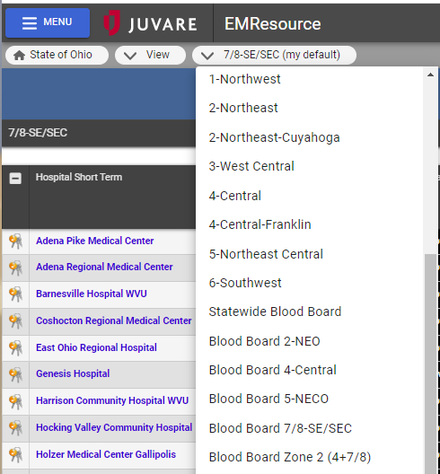
Click Here

- Find your hospital (resource) in the list and you will notice keys beside your hospital. This will take you to the status updates.
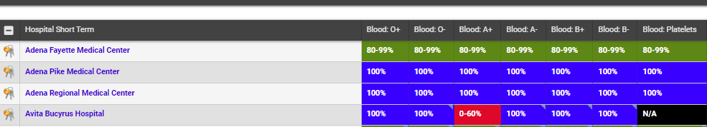
Click on the Keys

- Once at the status screen – click on “select all” at the top left of the screen to expand each status type.
Click Select All
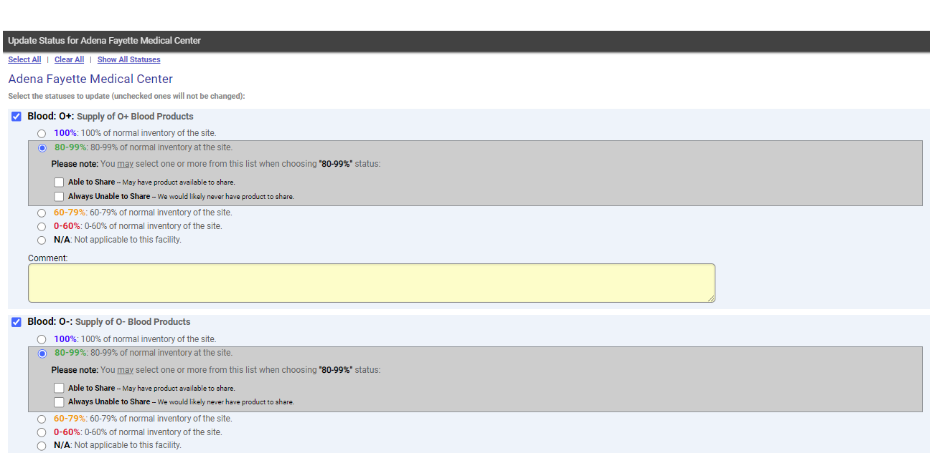

- Complete each status type based on your blood type capacity on hand and check the box if you are able to share. *You will also include any blood type requests you may have or short date units that will be expiring soon. Once done click save.
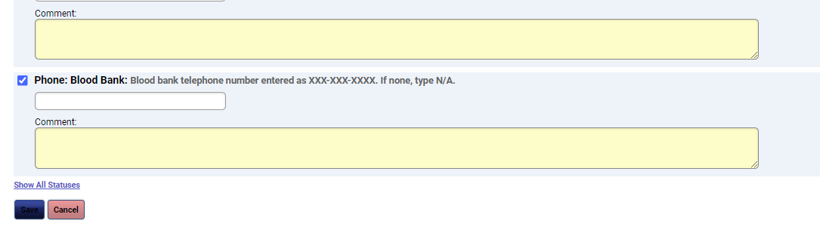
Click save once done

- Once you have completed entering your statuses and click save you will be re-directed back to the zone 2 blood board page where you can review your data and see the entire zone’s availability.
